
How to take SQL-IaaS to PaaS

Revised: 3/24/2021

By. Kyle Dougherty
Cognizant Microsoft Business Group
20 North Wacker Drive #530
Chicago, IL 60606

Notice of Confidentiality ©2021 Cognizant Microsoft Business Group All rights reserved.

IS SUBJECT TO THE TERMS OF THE COGNIZANT MICROSOFT BUSINESS GROUP NON-DISCLOSURE AGREEMENT. NEITHER THIS DOCUMENT NOR ITS CONTENTS MAY BE REVEALED OR DISCLOSED TO UNAUTHORIZED PERSONS OR SENT OUTSIDE THE AFOREMENTIONED COMPANY WITHOUT PRIOR PERMISSION FROM COGNIZANT MICROSOFT BUSINESS GROUP

Pre-REQUisite

Database must be accessible remotely – telnet port 1433
Install SQL Server Management Studio on a machine with access to the source and target DB
AzureSQL Instance w/ credentials

Azure Migrate
Create new Database Project in Azure Migrate
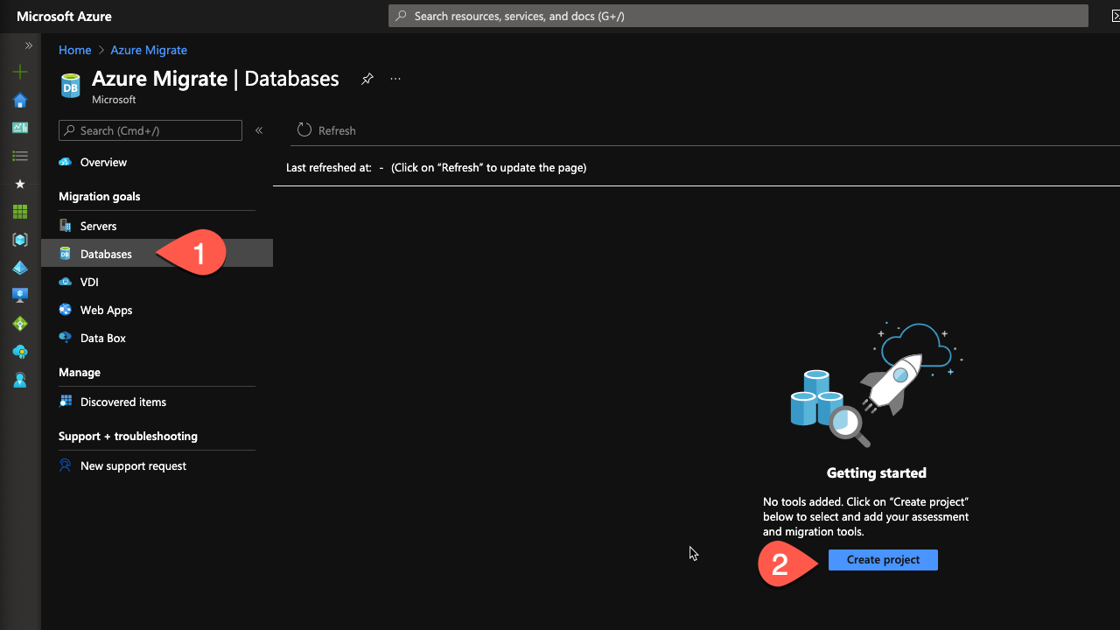
You’ll need to provide a Resource Group and subscription for this project if you have not been provided one by the client.

Assess Environment using Data Migration Assistant (DMA)
Download DMA
There will be a link on the Migrate project for the DMA tool. You’ll want to download it onto a location that has access to the source database like a jumpbox.
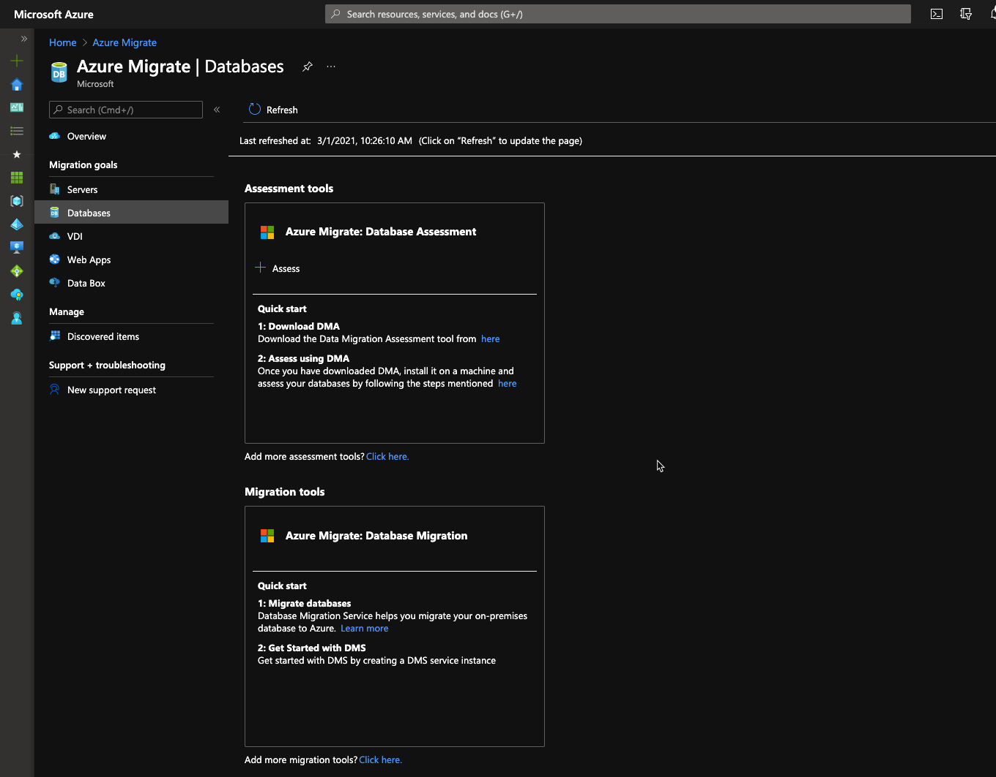
Create assessment project.
Open the Data Migration Assistant (DMA) and click on the + to create a new project.
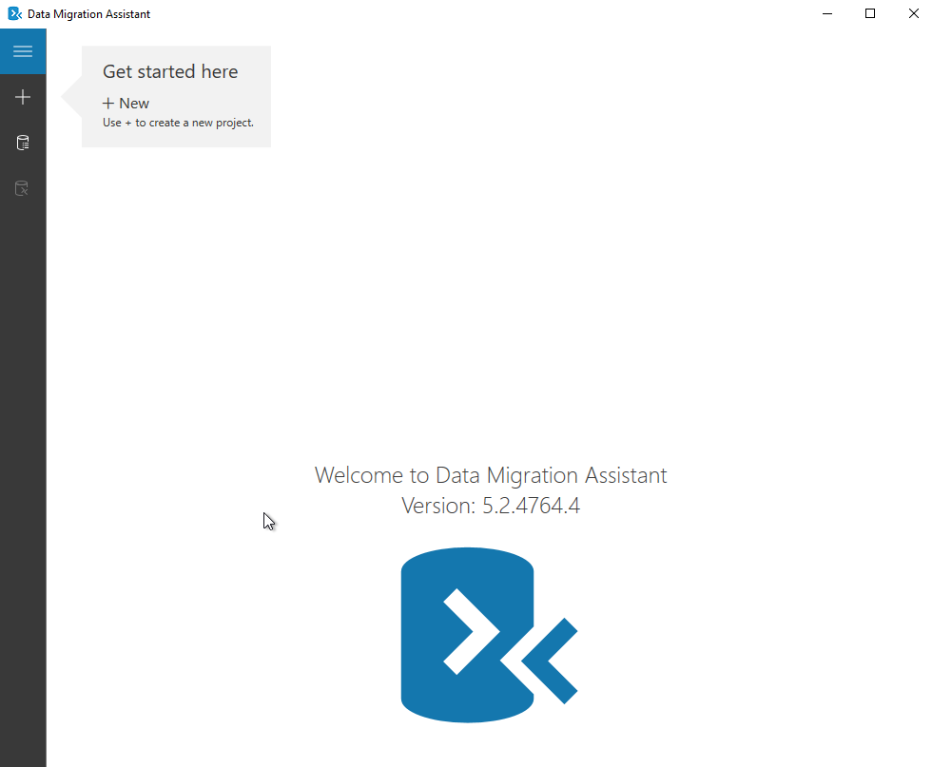
You will need to provide a project name, assessment type, source server type, and target server type. In this example, the source is a SQL server instance hosted on Windows Server 2016 and moving onto an Azure SQL instance.
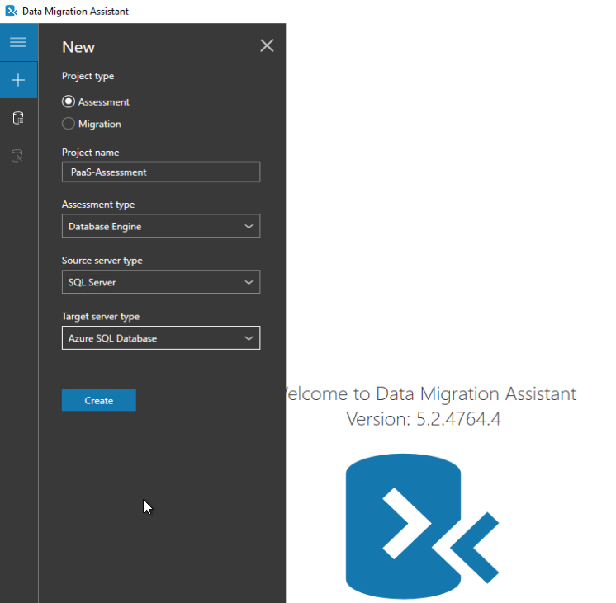

You’ll be provided with a list of options that the assessment will capture, by default it will check overall database compatibility and feature parity.
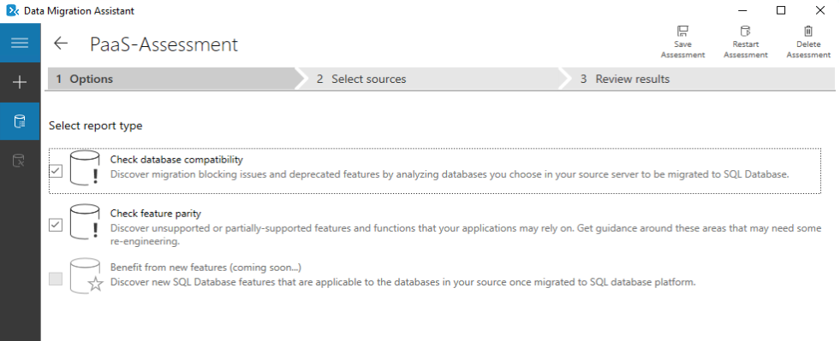
Provide the server name and authentication type for the source database
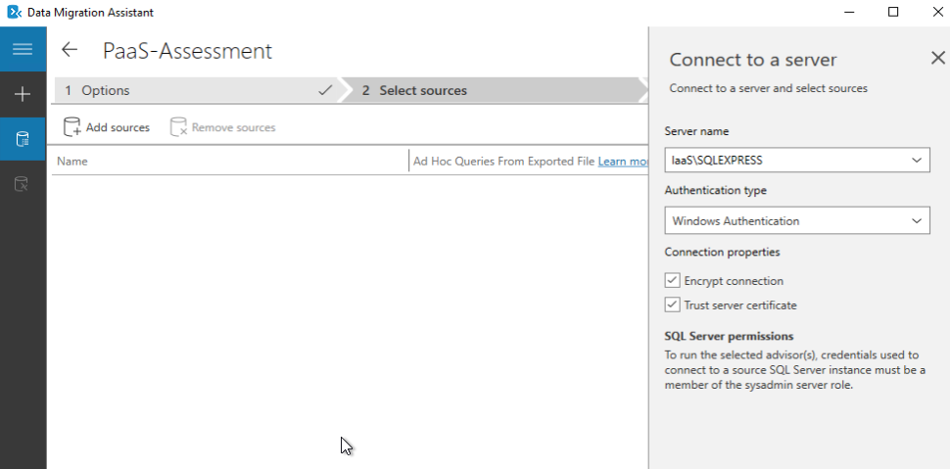
If there are multiple databases available on the instance, select only the database(s) that need to be assessed.
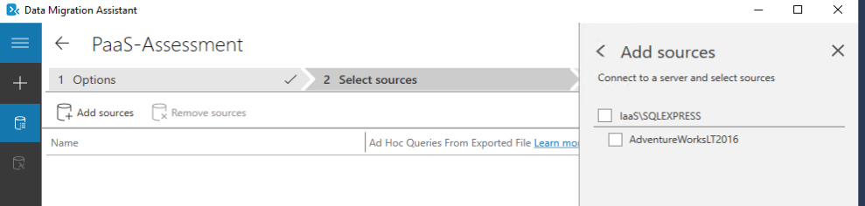
The results will be confirmed and the assessment can begin.
- Results and Upload to Azure
  - Check for feature parity and compatibility issues on the results screen.
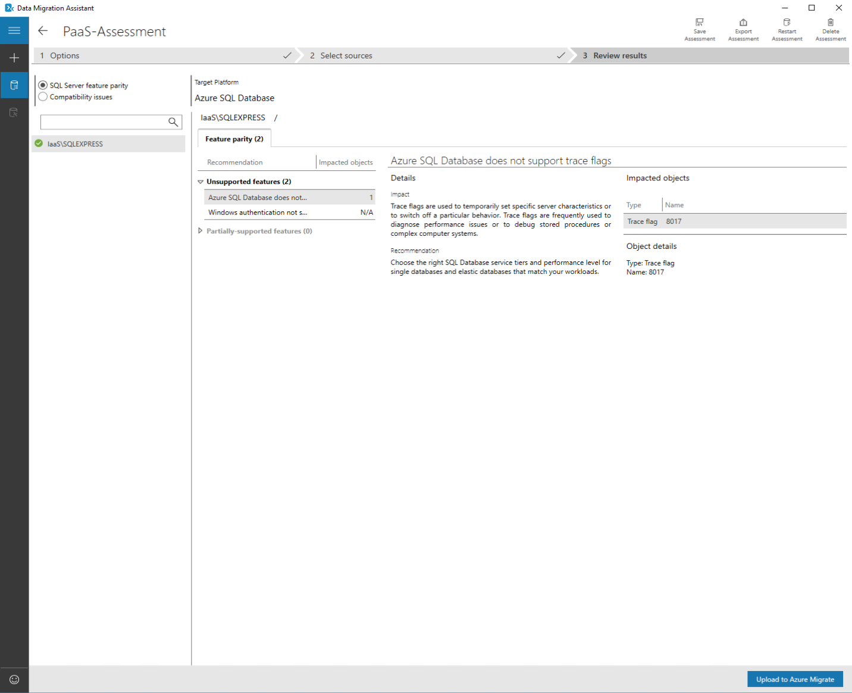
The DMA will allow results to be directly uploaded into Azure. Select the “Upload to Azure Migrate” to authenticate into the Azure portal and upload the results directly to the Azure Migrate Project created earlier.
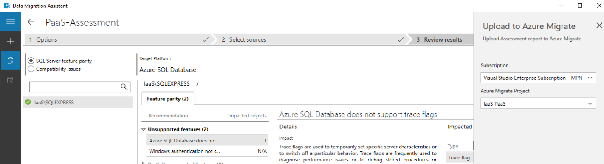
- Open Azure Migrate and review assessment.
  - This is to confirm that the data is present in Azure
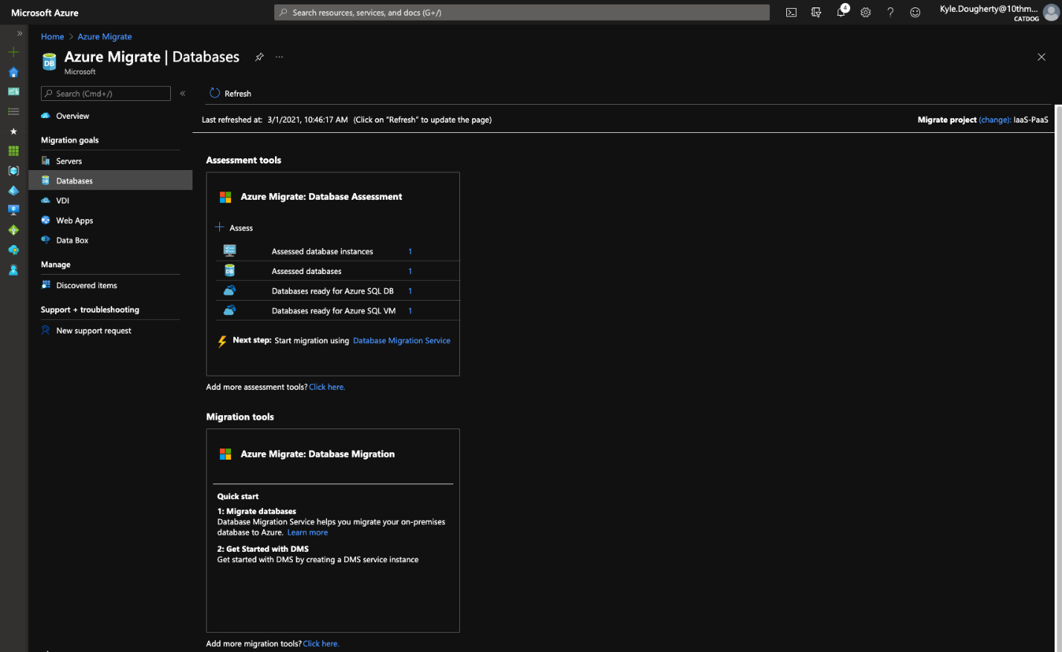
- Before moving on to step 3 or 4, ensure that the target database in Azure has been created and that the proper credentials are available.

Migrate using DMA
- Open the DMA and select new Migration Project. In this example, there will be a schema only migration and a data migration.
  - Schema Migrations migrate the ‘blueprint’ or structure of the database, but no data.
  - Data Migrations can be done after a schema only when it is time to fill out the database as it was on premises.
  - Schema and Data migrations do both functions in one operation.
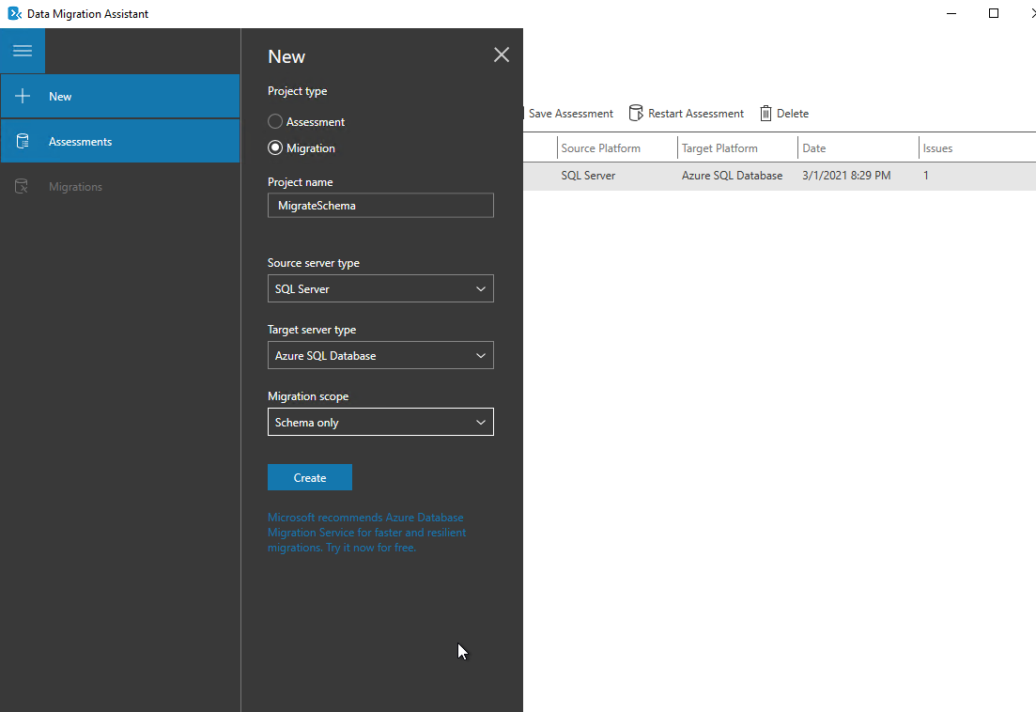
- Provide the source server information
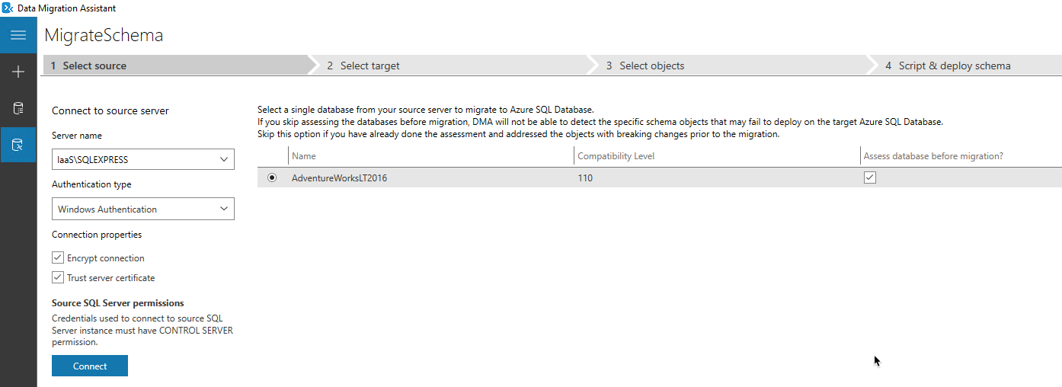
- Provide the target server information
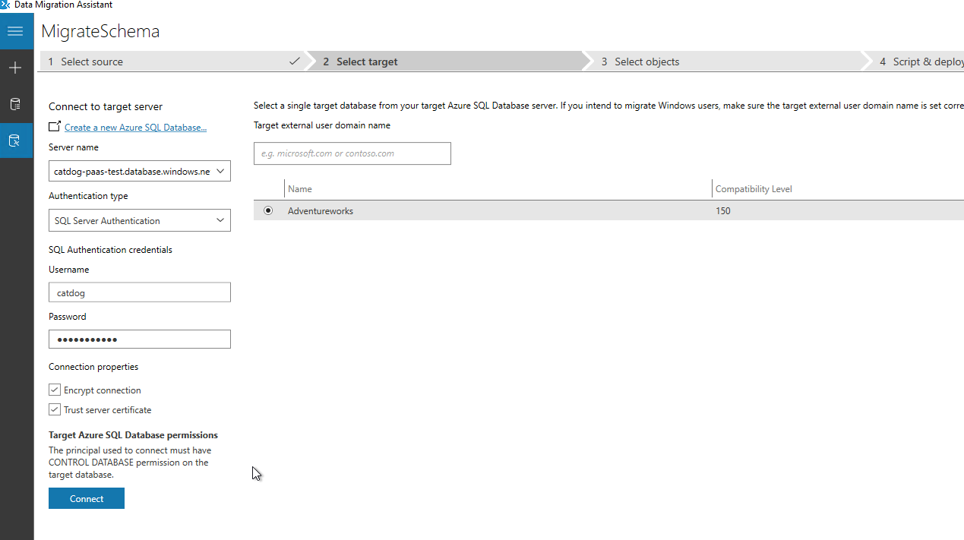
- Verify the schema listed is correct

- The DMA will generate a SQL script that migrates the schema into the target database. This script can be saved and run later or deployed directly through the DMA tool.
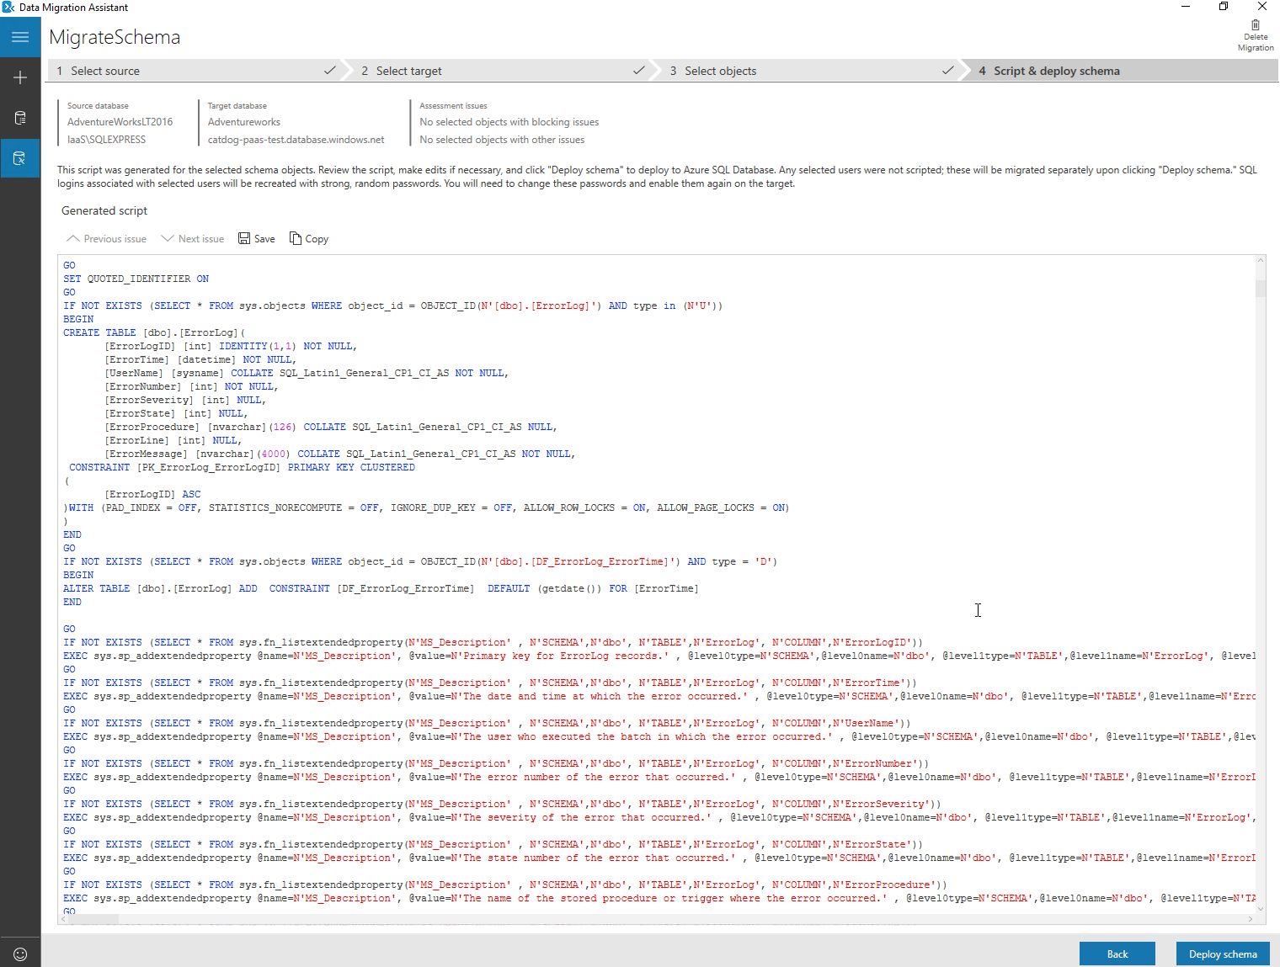
- The schema can be verified by connecting to the Azure SQL database using SQL Server Management Studio.
  - Data Migration follows the same process with little variation
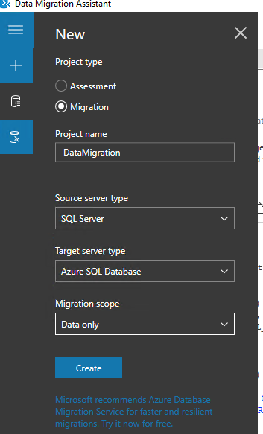
- Provide the source information
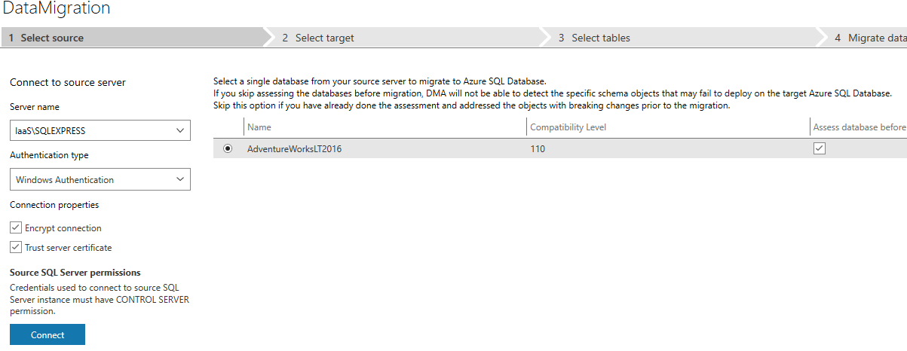
- Provide the target information
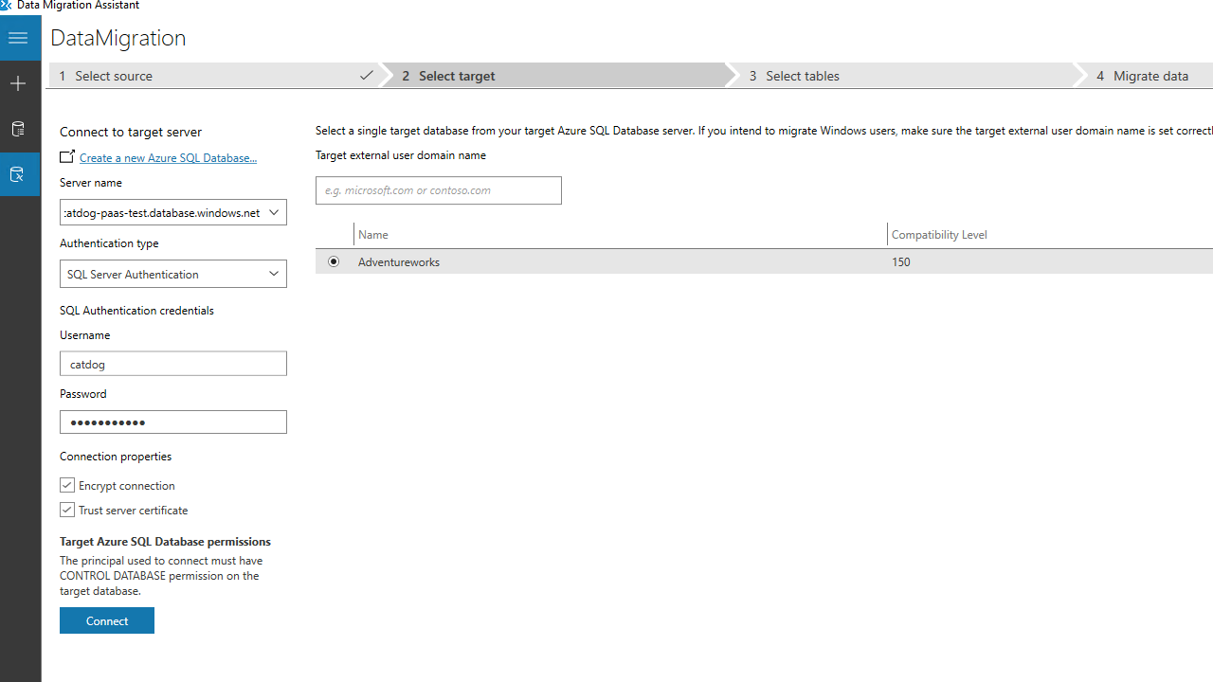
- Confirm the databases to be migrated
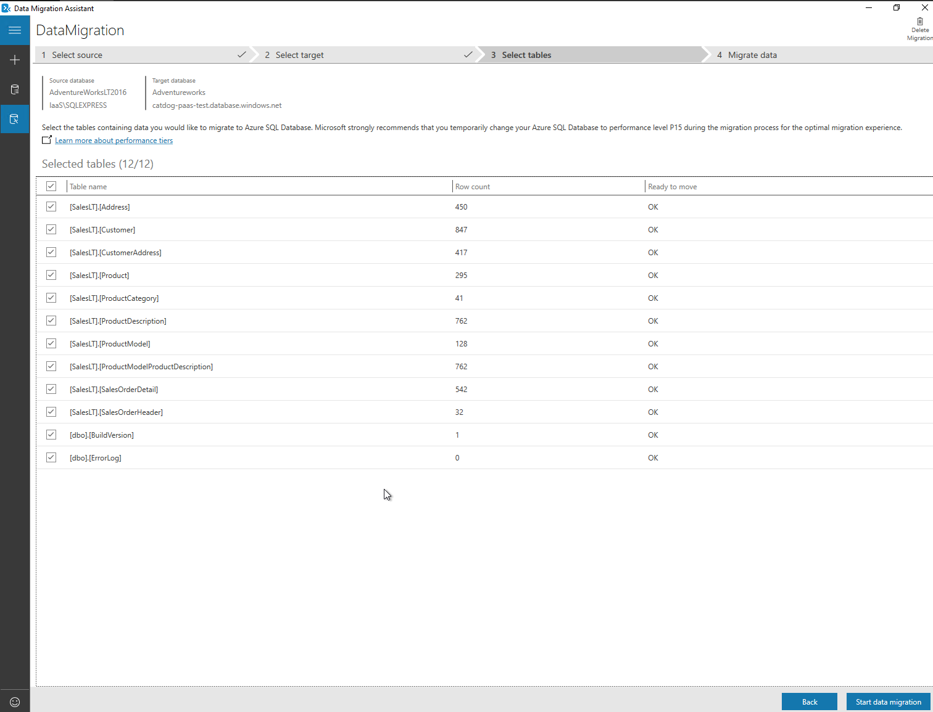

- Review the results

Migrate using Azure Database Migration Service (ADMS)
- Add Service from ADMS in portal
  - Premium tiers of this service allow for live migrations. Standard tiers omit this option.
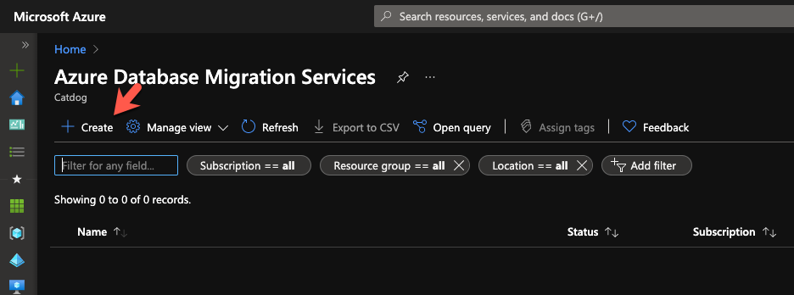
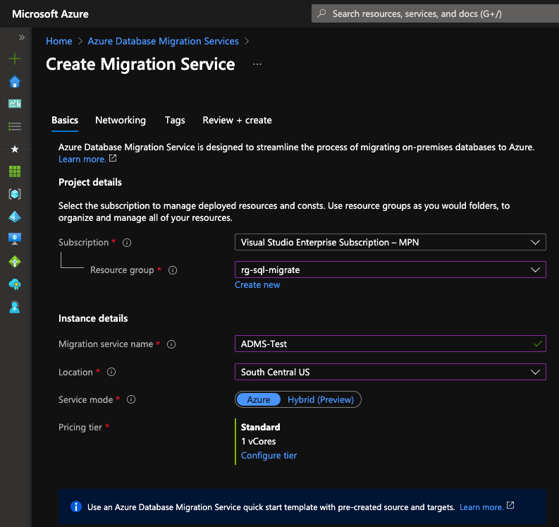
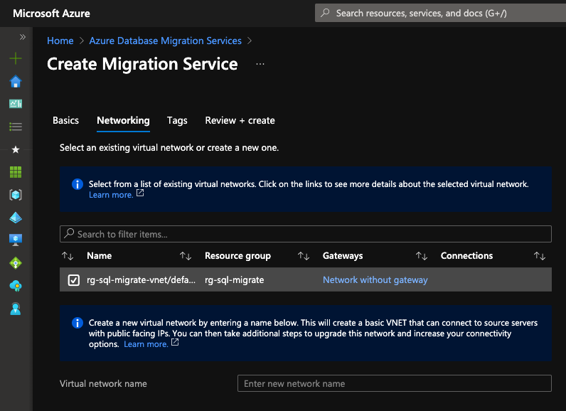
- Open the ADMS Create Migration Project
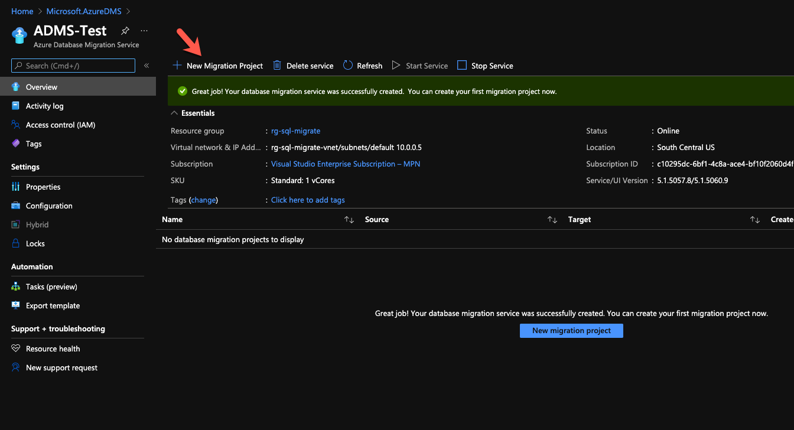
- Choose type
  - Schema Only – Structure or ‘blueprint’ of the database with no data
  - Data – Data only to fill the structure created in the Schema migration
  - Project Only
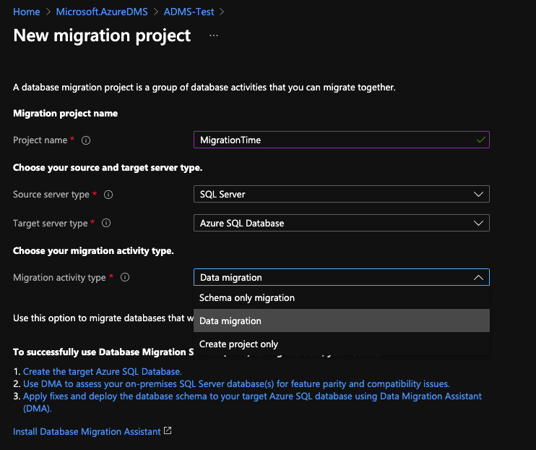
- Provide the source information
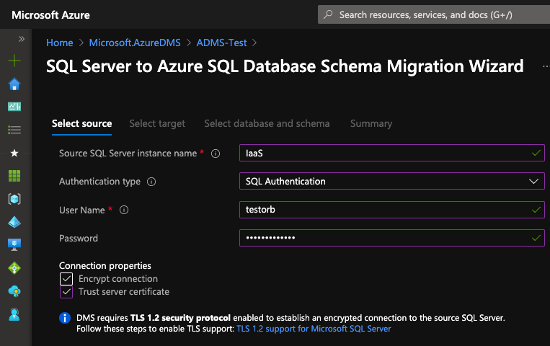
Provide the target information
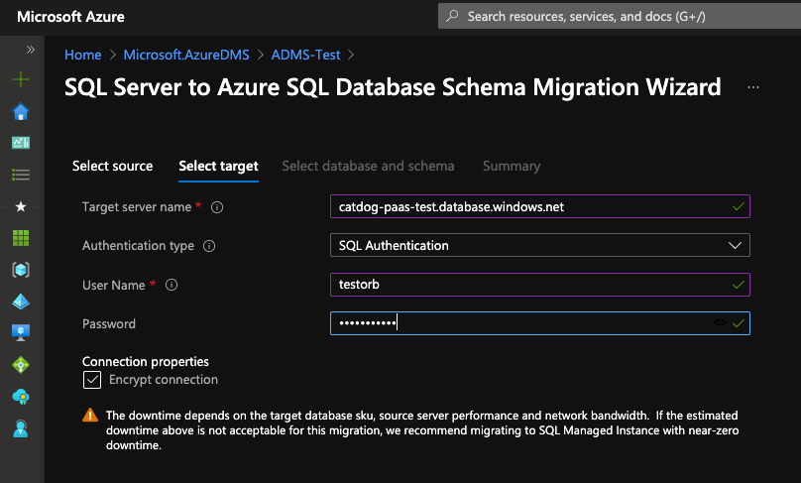
- Select the database(s) that are being migrated
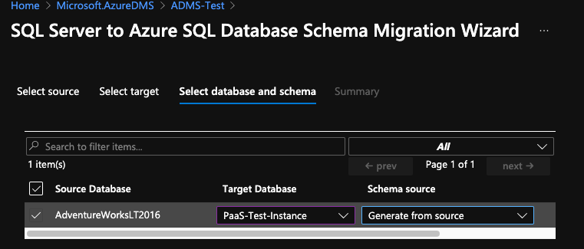

- (Data migration only) Configure which data is being migrated from the source database
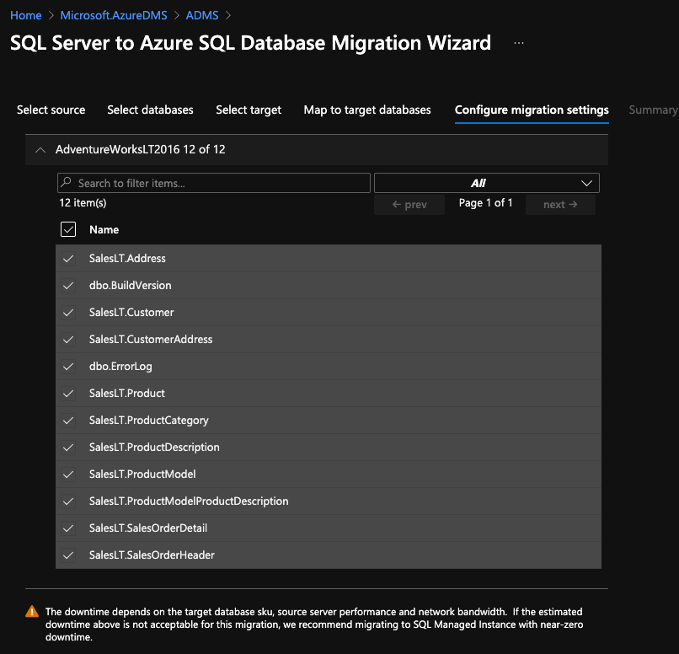
- Provide a name for the job and confirm all information is correct.
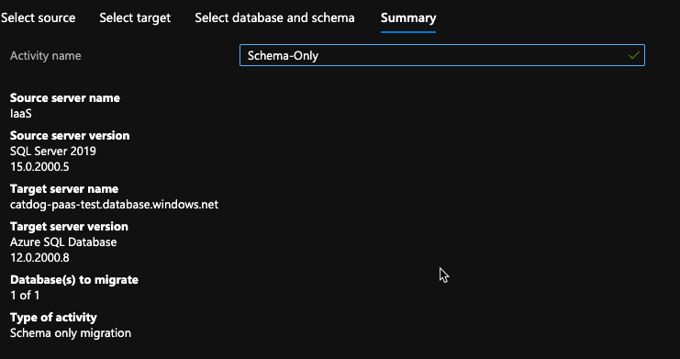
Confirm the data has copied properly by accessing the database using SQL Server Management Studio

References:
https://docs.microsoft.com/en-us/azure/dms/tutorial-sql-server-to-azure-sql
https://docs.microsoft.com/en-us/azure/dms/dms-overview
https://docs.microsoft.com/en-us/sql/dma/dma-assesssqlonprem?view=sql-server-ver15
https://docs.microsoft.com/en-us/azure/security/fundamentals/infrastructure-sql#:~:text=%20Security%20capabilities%20%201%20Usage%20of%20the,SQL%20Database%20gateway%20service%20called%20DoSGuard.%20More

